**3.What is Looping in python?**

**Objective:**

* To see the kinds of looping in python3.

**Process:**

* If loop.

It checks the condition is true, then its execute that particular block of code.

* For loop.

It executes a sequence of statements multiple times until the condition goes False.

* While loop.

Repeats a statement while a given condition is True.

It tests the condition before executing the loop body.

**Input:**

* Sample code for sum of digits using while loop.
* Sample code for sum of even number using for and if loops.

**Output:**

* Sum of digits.
* Sum of even numbers.

**Source code**(While loop):

#get input from user

n=int(input("Enter the number:"))

rev=0

#initiate while loop

while(n>0):

r=n%10

rev=rev+r

n=n//10

#print the result

print("sum of given number is:",rev)

**Source code**(for and if loop):

#get input from user

n=input("Enter the number:")

total=0

#initialize for loop

for i in n:

#Type casting(because we cant take integer input in loop)

a=int(i)

#initialize if loop

if(a%2==0):

total=total+a

#print the result

print("The sum even number in a given number is:",total)

**Screen shot:**

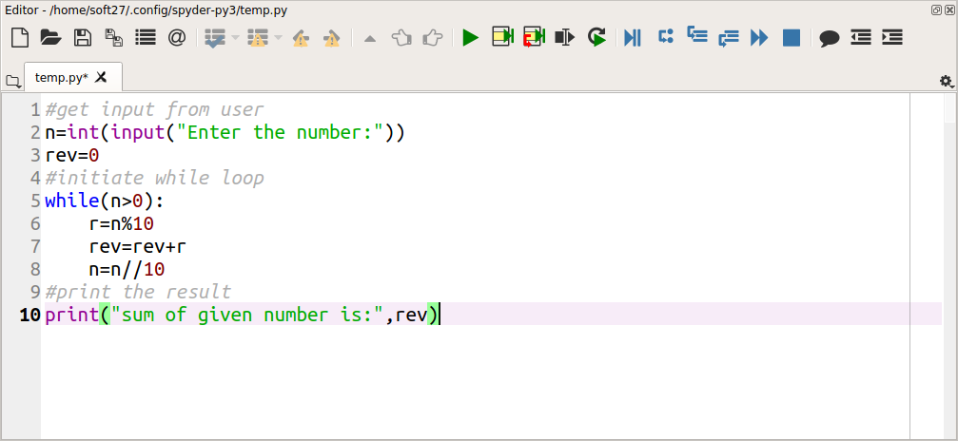

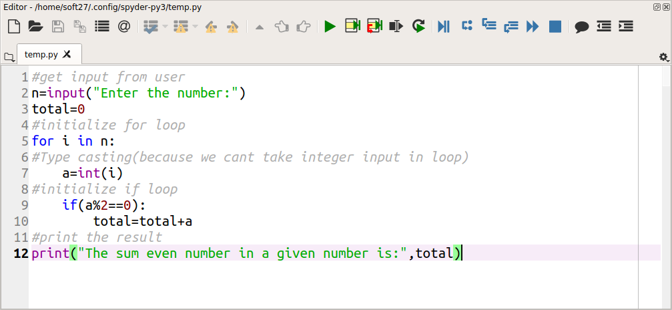

**Output:**



